|  |  |  |
| --- | --- | --- |
|  | | |
| My 2019 Summer Vacation | | |
| By: Tingxu LAN | | |
|  | BBQ • Coding • Podcast •  Chess Tournament • Family • Friends |  |

Table of Contents

**Foreword** 3

**June 14, 2019 Last Day of Elementary School** 4

**June 15, 2019 Coming to America** 6

**June 16, 2019 B.B.Q. with Friends** 7

**July 1, 2019 Day 1 of Modding Camp** 9

**July 4, 2019 Day 4 of Coding Mods Camp** 11

**July 8, 2019 Day 1 of UW Camp** 13

**July 9, 2019 Day 2 of UW Camp** 14

**July 16, 2019 Podcasting Week Two Day Two** 16

**July 20, 2019 See My Old Chess Coach** 17

**July 21, 2019 A Nice Saturday** 18

**July 24, 2019 An Unexpected Event** 19

**July 26, 2019 The 2nd Last Day of Summer in America** 20

**July 28, 2019 Going back to China** 21

**August 7, 2019 Chess Tournament – Arriving in Huangshan** 22

**August 8, 2019 Chess Tournament – First Day** 23

**August 8, 2019 Chess Tournament – First Day (Cont’d)** 24

**August 9, 2019 Day Two of the Chess Tournament** 25

**August 10, 2019 The Last Day of the Chess Tournament** 26

**Afterword** 27

# **Foreword**

I wrote this for my homework. In here is 18 days of my 2019 summer vacation. It contains real thoughts that I jotted down in my mind every day. It contains my real actions and words. It is about my challenges and happiness in America, and the sadness when I got back. It contains my real *feelings*. This is a real challenge to the current me, because I haven’t written in English for nearly two years. So, thanks to my parents for helping me finish these 18 pages when it got really tough. Thanks to my instructors and friends for being amazing people to be with during my journey. I’m looking forward to presenting you my story!

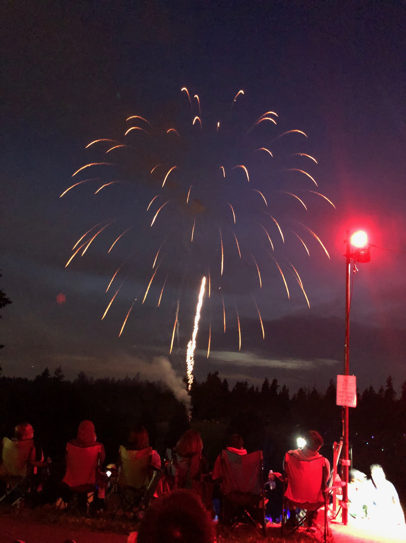

# **June 14, 2019 Last Day of Elementary School**

This was it. Time to say goodbye. Maybe forever.

Ring ring! Ring ring! Ring ring! Ring- I slammed my hand onto the clock hatefully: someday I ought to remember to close that evil thing. I sighed, knowing there’s no way I was going back to sleep again with all the excitement today. So, I opened my kindle (electronic book) and checked if any new books came out yet. Nope. Mad that I was awoken at 4 am, I slammed my head into my pillow, as if raging helped with anything. After burying myself in my pillow and doing nothing for thirty minutes, I decided to check my kindle again. Nope. Desperate of something to do, I downloaded a random book and read. The book was surprisingly good, and I got hooked immediately. Time flies fast when you’re focused, and before I knew it, it was seven. Whew. Stretching, I got out of bed slowly, already feeling the headache I get from not sleeping enough. I shook my head, getting ready for the last day of school. I didn’t know to happy or sad. I walked to school sadly, knowing it was the second-last time I would take this route. Talking to the security guy, rushing over to the bus stop, everything. No more.

But enough of the sad stuff. It was the last day of school! I attempted to cheer myself, which somewhat worked. There was nothing to be sad about. Sure, I won’t see my classmates again, but, being an introvert, I only had a few friends, and we could always talk on the new phone I’m getting. Sure, I’ll being going to middle school, which was scary, but there’s nothing I couldn’t adjust to yet in my life so, why should I be afraid? Plus, middle school is a new start, a chance to retry things that I’ve failed, a chance to change myself into a different me. A better one. And icing on the cake, I’m finally going back to America. That one really cheered me up.

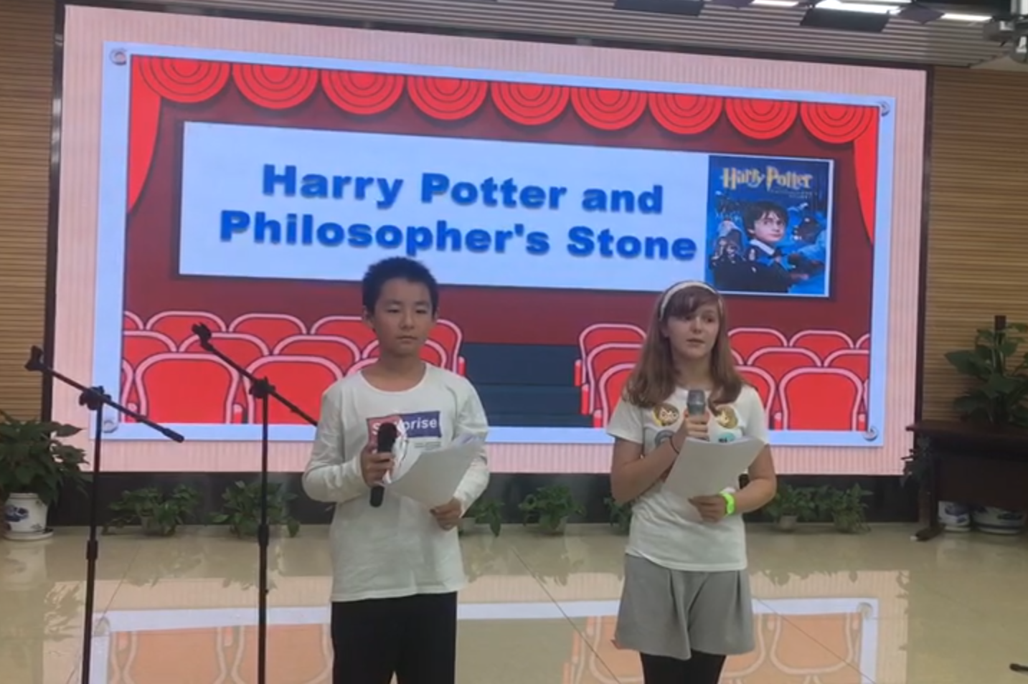

Lost in my own thoughts, I almost missed my stop.

Passengers whose destination is Xi Yi elementary, please exit now.

Startled, I jumped out my seat just in time.

Arriving at the school, it was just partying and the teacher talking. Almost everyone voted on watching a movie, since it was boiling hot today. I worked on my ***Grand Project*** (so grand I used all the word effects), which was writing a page including all their info and memories including them that made me smile. This way I could always remember my six-grade childhood.

At the end of “class”, everyone, and I mean everyone hugged each other. Enemies became friends, tears were shed, final goodbyes made. It was a truly beautiful moment. We walked out into the boiling sun, but no one complained. Even the class clown stood still, which was one of the few things our teacher failed at making him do. Our teacher announced: “School is over!” one last time, but this time no one rushed out. No one yelled. Instead, we stood in a line, everyone bowing silently at our teacher, each one giving a thank-you card. One, final gift. I could see our teacher smiling, trying not to be too excited. I took at last look at my school. It might be small, average, with a grumpy principle, but in my heart, its number one. “Goodbye” I whispered to the school, “I’ll never forget you.” And with that, I left.

# **June 15, 2019 Coming to America**

Yesss! I’m going home! Its summer vacation, and me, my dad, and my little sister, are going to back to America. Ever since coming to China, we did this every year.

After my grandparents bid us a teary farewell, we got on the taxi and began our journey to America.

We arrived at the airport, and I read for the entire time waiting for the airplane to come (Cause’ I really like reading). My sister went to a Karaoke booth, but I didn’t want to because I didn’t want to be embarrassing, since I sing like a pig.

My sister was especially happy, soon she will finally get to see our mom. The last week she’s been crying at night yelling for mommy. As we boarded the plane, my sister sang some more mom-related songs she created. On the airplane, we asked a nice old lady if we could switch spots and she said yes. So, we sat together. I turned on the screen and started watching TV. My sister did the same. One of the best parts of travelling is that we get to use the screen for the entire time, since my dad usually sleeps. I played some scrabble after that. Then it became a cycle: eat, watch TV, get bored, play video games, attempt to sleep but fail, then watch more TV.

“We arrived at Sea-Tac airport, hope you enjoy your flight, and thanks for choosing Delta airlines.” We got off the airplane, and suddenly, mom appeared out of nowhere. My sister screamed in delight, and even I almost forgot about maintaining a casual appearance. We finally got to talk to mom for the first time after one week. I felt the usual nostalgia of coming back from America, seeing Sammamish, breathing the sweet, sweet air, see the trees… We drove to Summer Ridge and got our stuff from our friend Ethen. After continuous complaining from me and my sister saying we’re too tired, we drove to the hotel. And before I knew it, I was asleep.

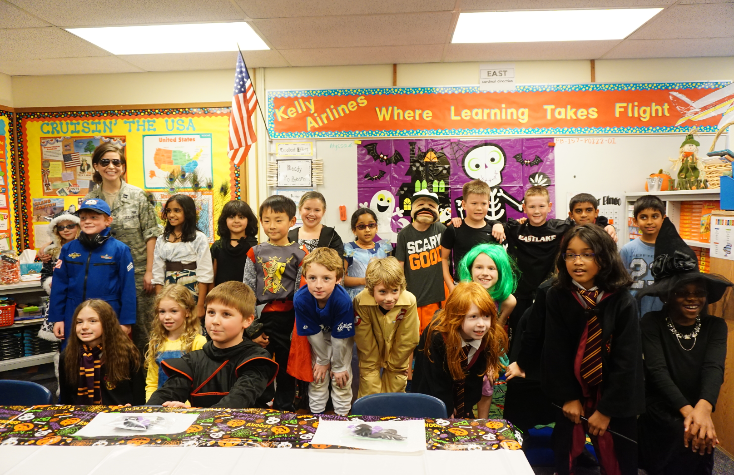

# **June 16, 2019 B.B.Q. with Friends**

I woke up well rested after yesterday’s jet lag. I looked at the clock- it’s twelve twenty already. Yawning, I climbed out of bed and put on my clothes and stretched. Soon later, my parents woke up. We ate some brunch at the Pancake House, the place I used to love to eat. I smelled the sweet, sweet smell of pancakes and almost fainted. I almost forgot how much I loved this place! I ordered some bacon pancakes, a family favorite.

“Ding!” The food arrived. I took a small bite. “Mm!” This was really good! Time passed by *way* too fast, and before I knew it, even my sister, a picky eater, was done. We drove home and we watched some YouTube. I haven’t watched my favorite channel, TheOdd1’sout in what seemed like *centuries*! After me and my sister enjoyed some good quality YouTube, we went to see my old friends at a BBQ party.

We drove to the beach and Ethan’s mom led me to the group. “Hey guys?” I said nervously. No one responded, all too focused on…building a castle. “I guess we’re still resuming the tradition of castle-building, huh?”

“Yep.” Diana replied.

Diana, a short haired girl known for leading *everything,* Corey, the guy who made good jokes and has a bowl cut, Kylie, the gamer, Vincent, the *boy* gamer, and even Anthony, a tall, strong guy who was known as “Mr. Cool” since he was and was cool with anything, (who moved away) was here, too, all building the castle. Ethan was just standing there doing nothing as always, everyone looked the exactly the same (only a bit taller) just like when we were 9. Only that Sean wasn’t here. And I was being super awkward. For a while, I didn’t know what to say, having not being here for a year. After a while we went back to the BBQ place and ate food. Finally, Sean arrived, and he looked completely different. Like through puberty. He was slimmer, wore glasses, and had freckles. We two talked the most and we started chatting and I added his WeChat.

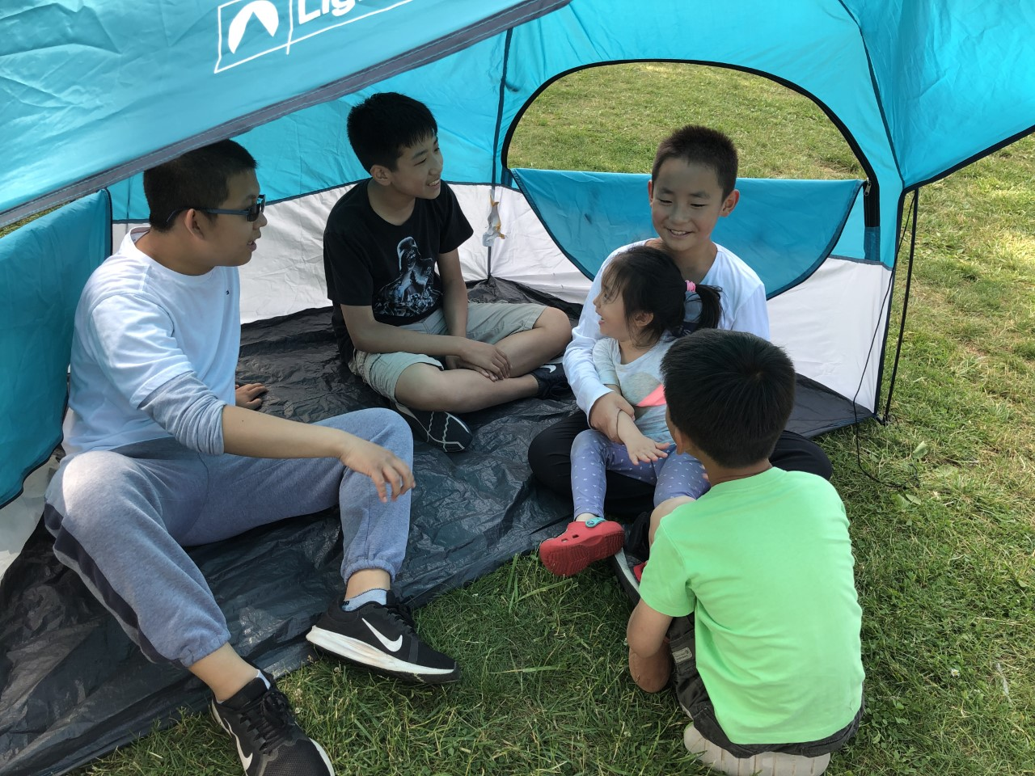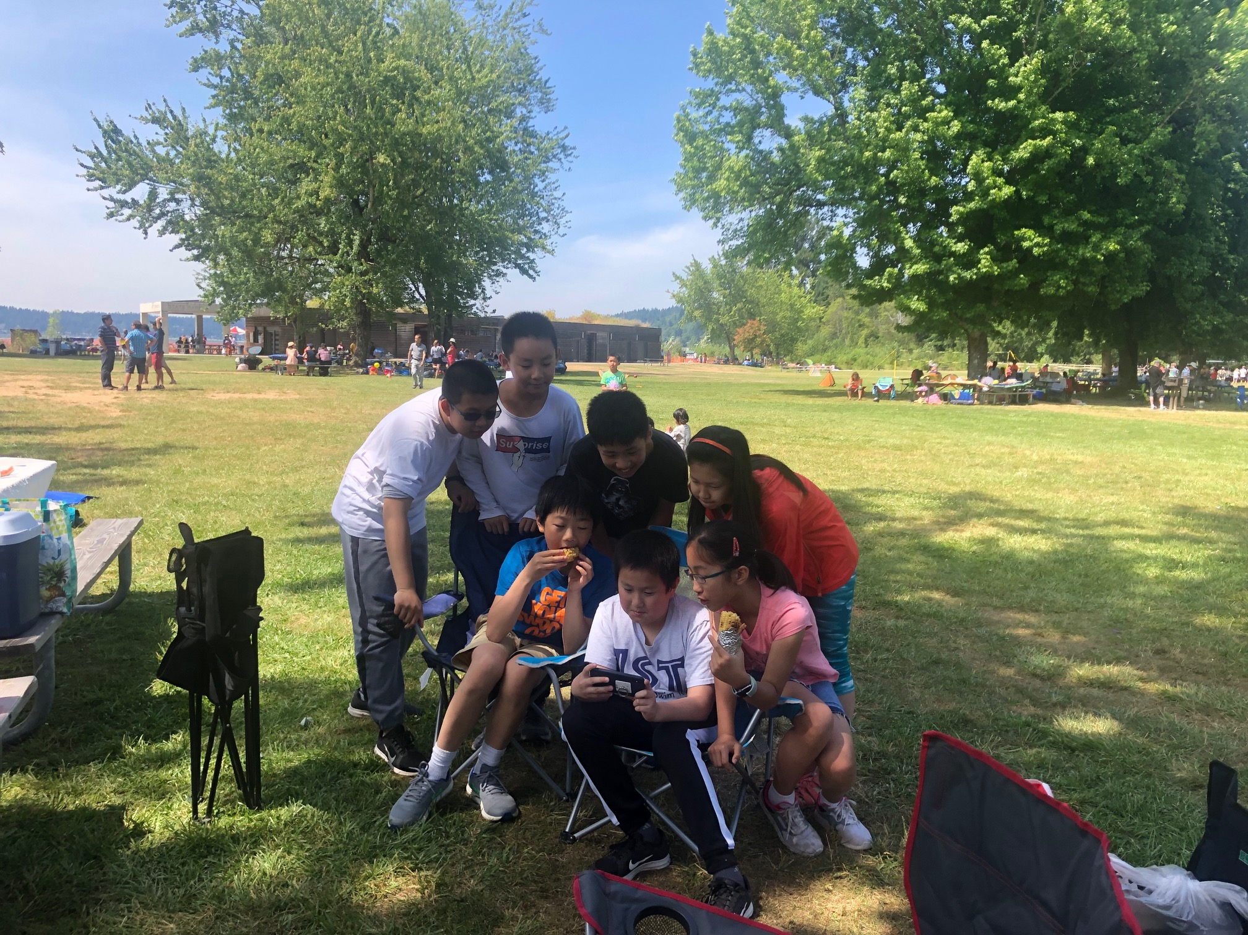

“Hey guys wanna play some socccccccer?” Corey asked? Everyone rushed to take the ball, and that’s when I started getting less awkward, being the soccer guy. “Woops!” I taunted Kylie as I juked her easily. Soon later everyone got tired of me crushing them and did some group jump rope. We had fun complaining to the moms that they ruined every jump. We also played some video games, but I had no idea what it was since it was the new American trend. Similarly, no one knew the video games I played in China. Still, I got some laughs making jokes about the game’s ridiculous name (which is called “Brawl Stars”). Before we knew it, it was time to go home. I was pretty sad, but also relieved that things went well.

Feeling good about myself, I slept soundly that night.

# **July 1, 2019 Day 1 of Modding Camp**

I went home smiling. Today was a good day.

That morning my mom dragged the sleepy me into the car.

“Wake up, Max!”

“Huh?” I replied groggily, eyes barely open.

“Stop sleeping! Time for camp!” My mom said in Chinese.

We arrive at the camp located at Bellevue Community College.

In front of me was a green sign that said: “ID camp inside.”

So, I walked inside, and I saw some kids my age circling up. I was too nervous to go over there, so I just stood there, grabbing my backpack, looking extremely awkward. Finally, one of the instructors noticed me, and smiled. He shouted in a friendly voice: “Hello! Want to come over here and play ninja?” I cautiously walked over to the group and entered the circle.

“You know how to play ninja?” Asked the instructor.

“Yes.” I replied.

We played ninja for a while, which is a game where we try to hit each other’s arms in one fluid motion. A lot of people were goofing around, not moving or making jokes about their moves, which made me a bit more comfortable.

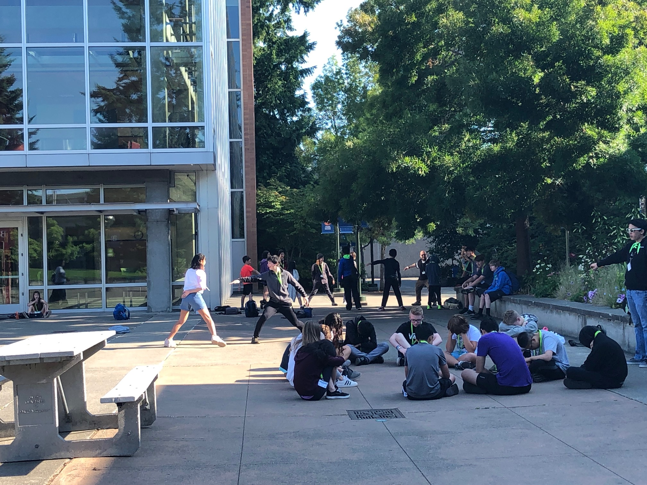

We played some more games, than we introduced all the instructors who had nicknames, like Gizmo or Lil’ Dipper. Our instructor was Elliot, a big-eyed Asian man wearing glasses.

He led us up to our classroom and introduced himself.

“Hi guys, I’m Elliot, and I’m a student at the University of Washington, and we have exams, so if I’m looking at my phone just know that I’m not texting.”

We used a program called IntelliJ, which allows us to use java code and import our mods into Minecraft.

We had technical problems, so we started late. Since I already knew the basics of coding, I immediately dived into the starting projects. The squeaky ball was first. Every lesson didn’t give me the solution, so I had to solve the problem on my own. After *tons* of frustration, I finally finished it. I loaded it and proudly showed it to my neighbor, Daniel, who is also an Asian boy my age. I soon became addicted and reluctantly left the room for recess time, which all I did was sit in a corner and think about my projects.

We went inside again. Suddenly, I heard people screaming: “Guys look what’s that?!” I ran over and saw that Ian’s computer had creeping mold growing. Everyone oohed and awed see the creeping mold grow. I was a bit jealous; I’m one project away from that. But Ian saw me confused at the code for the mold and quietly walked over.

“Hey, you could use my code.”

I turned over, and my cheeks turned red. He probably heard what I was muttering about.

“No…No thanks.”

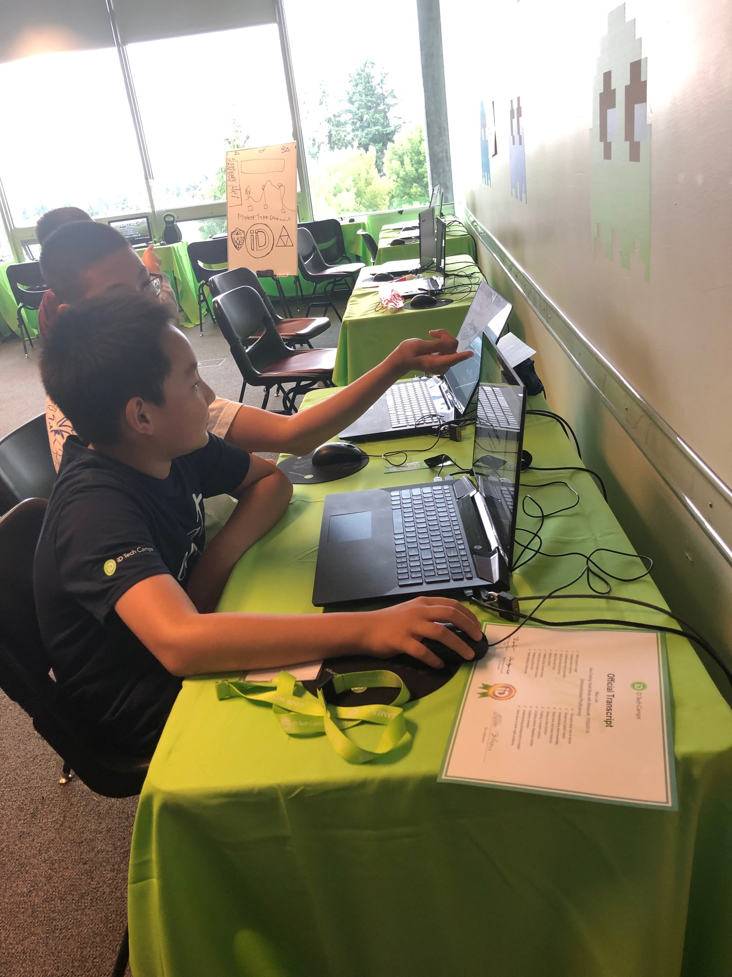 “Ok.” He replied, then walked back to his chair.

Feeling awkward, I shouted:” Thank you for asking though!”

Ian nodded without looking back.

After that it was almost time to go back home and we did shout outs. I felt really bad after no one gave me shout outs cause’ I had no friends. Tomorrow I was determined to socialize more.

# **July 4, 2019 Day 4 of Coding Mods Camp**

“Yay”! Today is July 4th. It’s also the fourth day of coding Minecraft mods with Java camp. I wake up early in the morning enthusiastic, but not for what you might think. Truth is, I really don’t care about Independence Day. First of all, I’m Chinese. So, I really wasn’t *that* excited (maybe not excited at all). Plus, the fireworks usually suck. Sooooo, yeah. I’m really just excited about getting to do more coding and modding (I’m not much of an outdoor guy).

At camp, we finally started doing our adventure maps, which is a Minecraft project we work on featuring our mods.

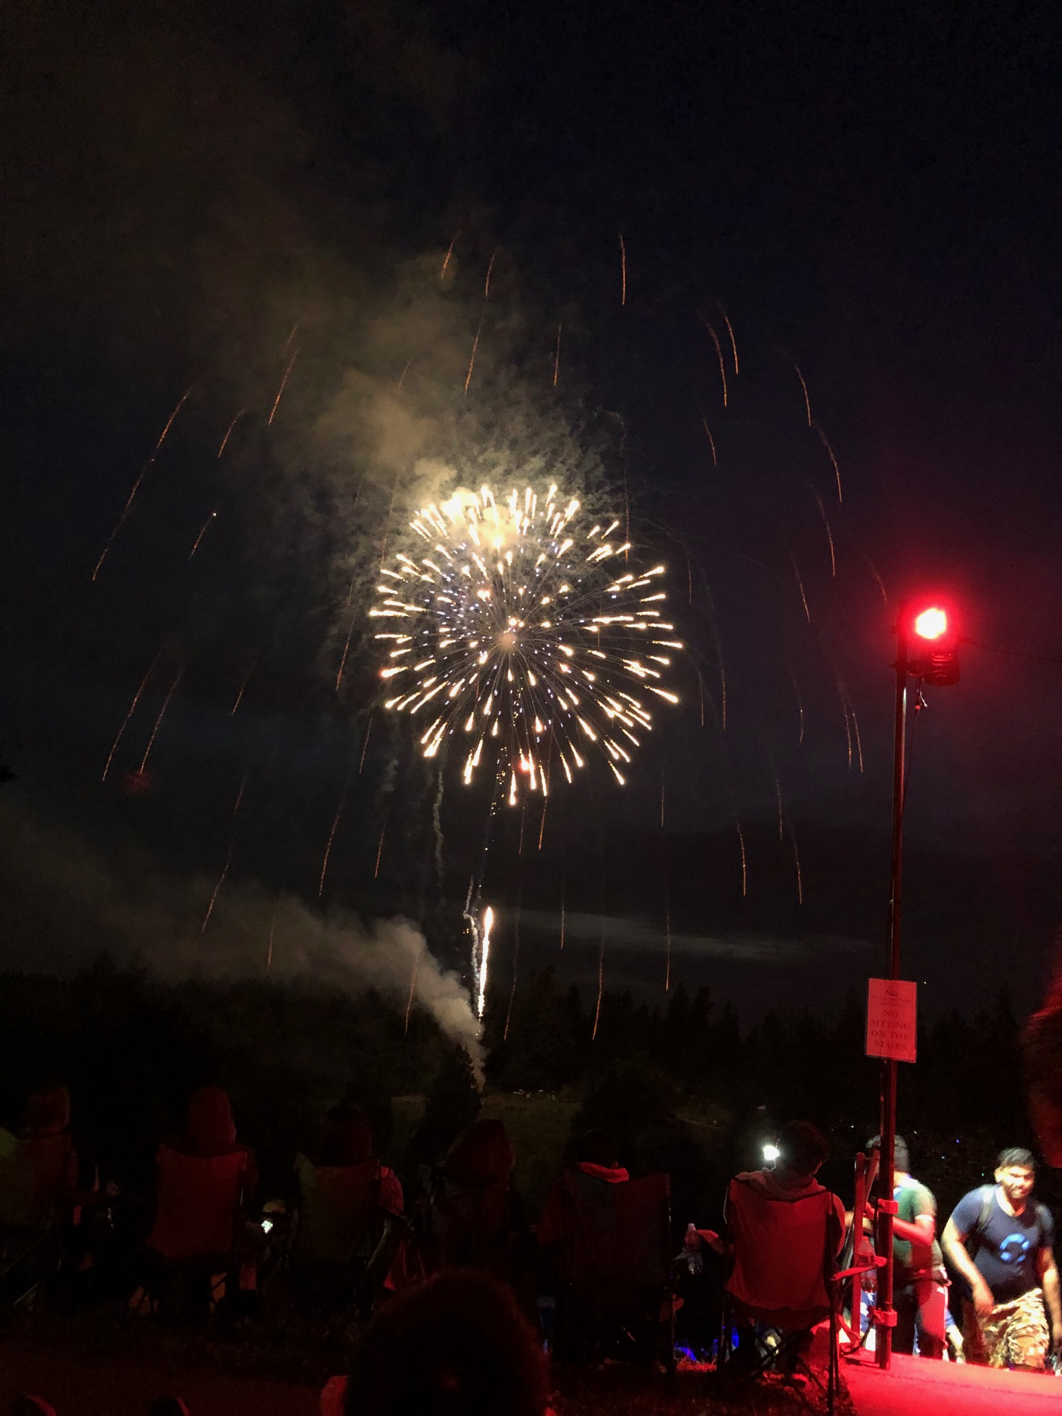Mine (in my opinion) was pretty cool. I added three trials: Trial one is a short but hard parkour course with arrows trying to knock you off. I added the flash apple if you wanted to try hardcore mode. Trial two is an also short but even harder trial featuring a gliding course. At this moment I would like to give my thanks to my kind of-friend, Daniel for giving me the idea of adding lava, which made it harder and way more viewable. The third trial isn’t all that creative at first (it was a mob fight), but I made it much more fun by adding dispensers on the top throwing invisibility potions. It was a devastating combo with my custom assassin mobs.

And then it was time for the fireworks. We drove there ten minutes before the show, which was not surprising due to my mom’s track record of being late. We had to run, and my mom was screaming the entire time. By the time we got there, even I, the most athletic person in the current family (my dad went back to China early), was panting and sweating. My little sister was crying after being carried around so roughly. “*Great,”* I thought sarcastically, *“I* almost *forgot why I hated this day.”*

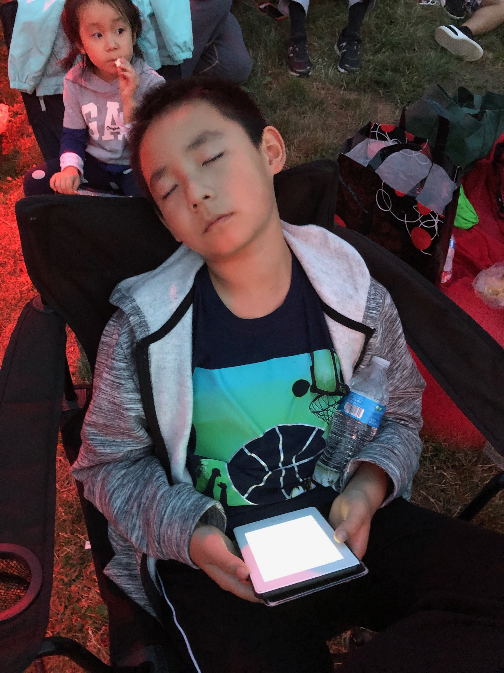We quickly settled for an average spot on the grass field. I gazed at the beautiful mountain far away; it was sunset already, and the sun casted an aura around the mountain, which gave a mystical look to it. “Boom!” The sound rang in my ears painfully as I flinched. The fireworks started abruptly, and with a bang. A quick combination of fireworks launched into the sky, which immediately burst with gold, red, green and blue. Everyone cheered, and even I raised my eyebrows. *“Hmmm,”* I thought. Maybe this year will be different. And it *was* different. Sammamish definitely had money to spend this year: there were way more fireworks, and almost none of them were repeated. There were some new ones; my favorite was a fire work that multiplied into sparks that had a variety of colors. My sister, though, did *not* enjoy all the loud noises. I sighed, I guess she’s still a baby.

After the fireworks I realized how tired I was. I fell asleep in the car content. Tonight, was a night to remember.

# **July 8, 2019 Day 1 of UW Camp**

Today was the first day of a three-week podcast camp at the University of Washington. In the morning we pulled sticks to decide who is sitting where. Then the instructor introduced himself, Arin and his two helpers, Davin and Jamie. Davin had messy, brown hair and was wearing a baseball cap. Jamie was a black man with long chin and a tallish build. This part was a *bit* embarrassing because my mom was really worried about me and kept double checking that I was fine. In the morning we spent time getting to know each other and setting up class norms. There are fourteen people in our class, half boys and half girls.

Time flew by really quickly and before I knew it, it was time for lunch. I was a bit worried since almost everyone already had someone to talk to, and I was just standing there awkwardly, not knowing what to do. Suddenly, an Asian boy came up to me. He looked a bit like me: medium height, little bit fat, and wearing an un-stylish t-shirt.

“Hello, I’m Ivan. Want to get lunch together?” Ivan asked me, with a slightly Chinese accent. I was both relieved and worried since I’m a bit shy.

I replied as smoothly as I could: “Sure.”

We went into the Hub, which was the place we were getting food. We decided to go to the DUB street burger place since it was too crowded to go any further. As we waited in line, Ivan was playing video games and we chatted on how the game earns money. Then, one of my friends, Alex, comes.

“Hey Alex.”

“Sup, Max. Long time no see.”

“You’re going to this camp too?”

“Yep.”

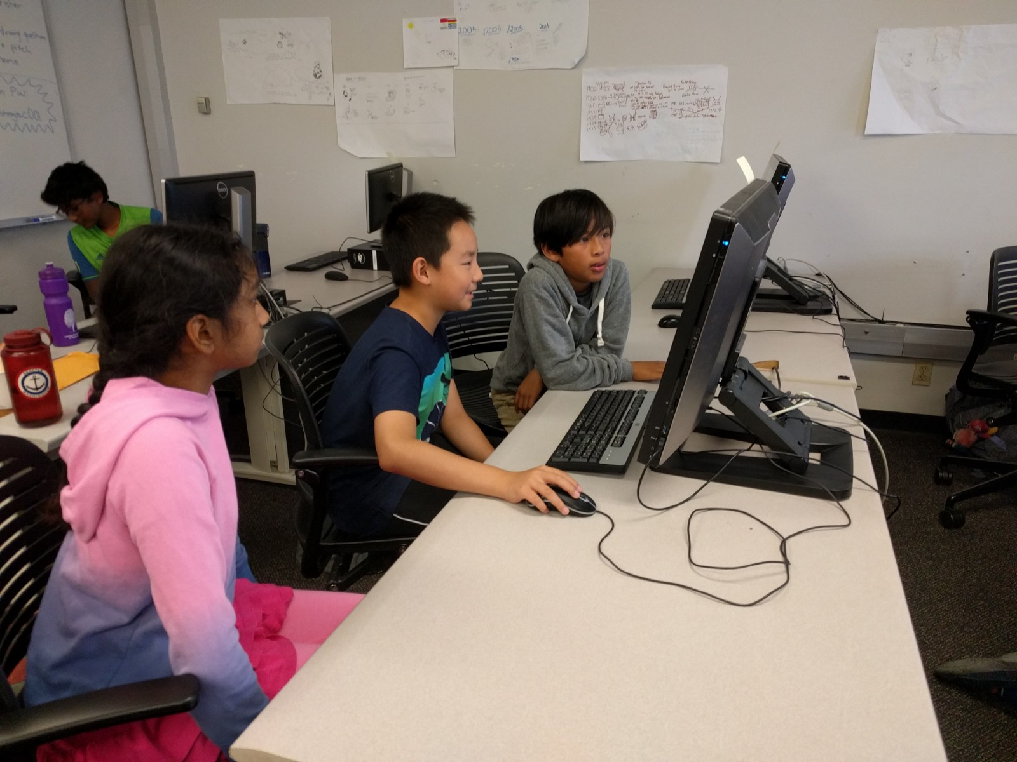Then Alex looked at our line and grinned: “I am *definitely* not going to wait in this line.” Before I could respond, Alex ran away.

I looked at our line and silently swore under my breath. Now there were no crowd blocking my view, I discovered that the line was *much* longer than we thought it was. Guess burgers where more popular than expected. It was too late to change lines, and by the time I and Ivan got our food, we had five minutes left, so we had to bring our food back to class. In my opinion it was worth it, because the food was *so* good. Soon people were asking for free fries.

In the afternoon we drew posters about the history of broadcasting and podcasting, and I really learned a lot about the basic concepts of podcasting. After that we listened to a ninety-year old radio station and a modern podcast to learn more about the difference of broadcasting and podcasting and how they changed. I also learned that tomorrow we were going on field trip to KEXP radio station to learn more about broadcasting and recording.

After I went back home, (I’m living in a friend’s house) I directly went upstairs since I have cat allergies and they have two cats. Me and my friend Kylie played on the computer for a while, then I went to sleep, excited about tomorrow’s field trip.

# **July 9, 2019 Day 2 of UW Camp**

Today is the second day of my podcasting camp at the University of Washington. I woke up in the morning sleepy but excited: today we were going to a field trip to the well-known radio station KEXP. We arrived just in time at the University. I quickly finished my writing prompt of the morning and followed the group to the bus station. We also got buddies (in case we got lost), which was the person next to you. Mine was a short, Philippine boy named Rocco. We set next to each other in the bus and I watched him play Clash Royale. We didn’t talk much but neither of us minded that.

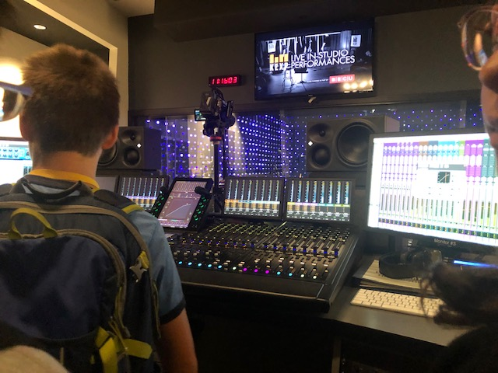 Screech! We arrived at our destination, which was downtown Seattle. It smelled bad and there was a lot of homeless people. Luckily, the walk was short, and we soon arrived at the station. It was much more different than I expected: the building was rectangular, there was a coffee chop and a LOT of people chattering. It looked more like a Starbucks shop than a radio station. We sat next to a modern art wall, featuring some guy called Prince. I took some pictures as we waited for the tour guy to come. Finally, a fat man wearing a cowboy hat came.

“Hey guys, my name is Triston, and I am your guide for today!” Triston said loudly.

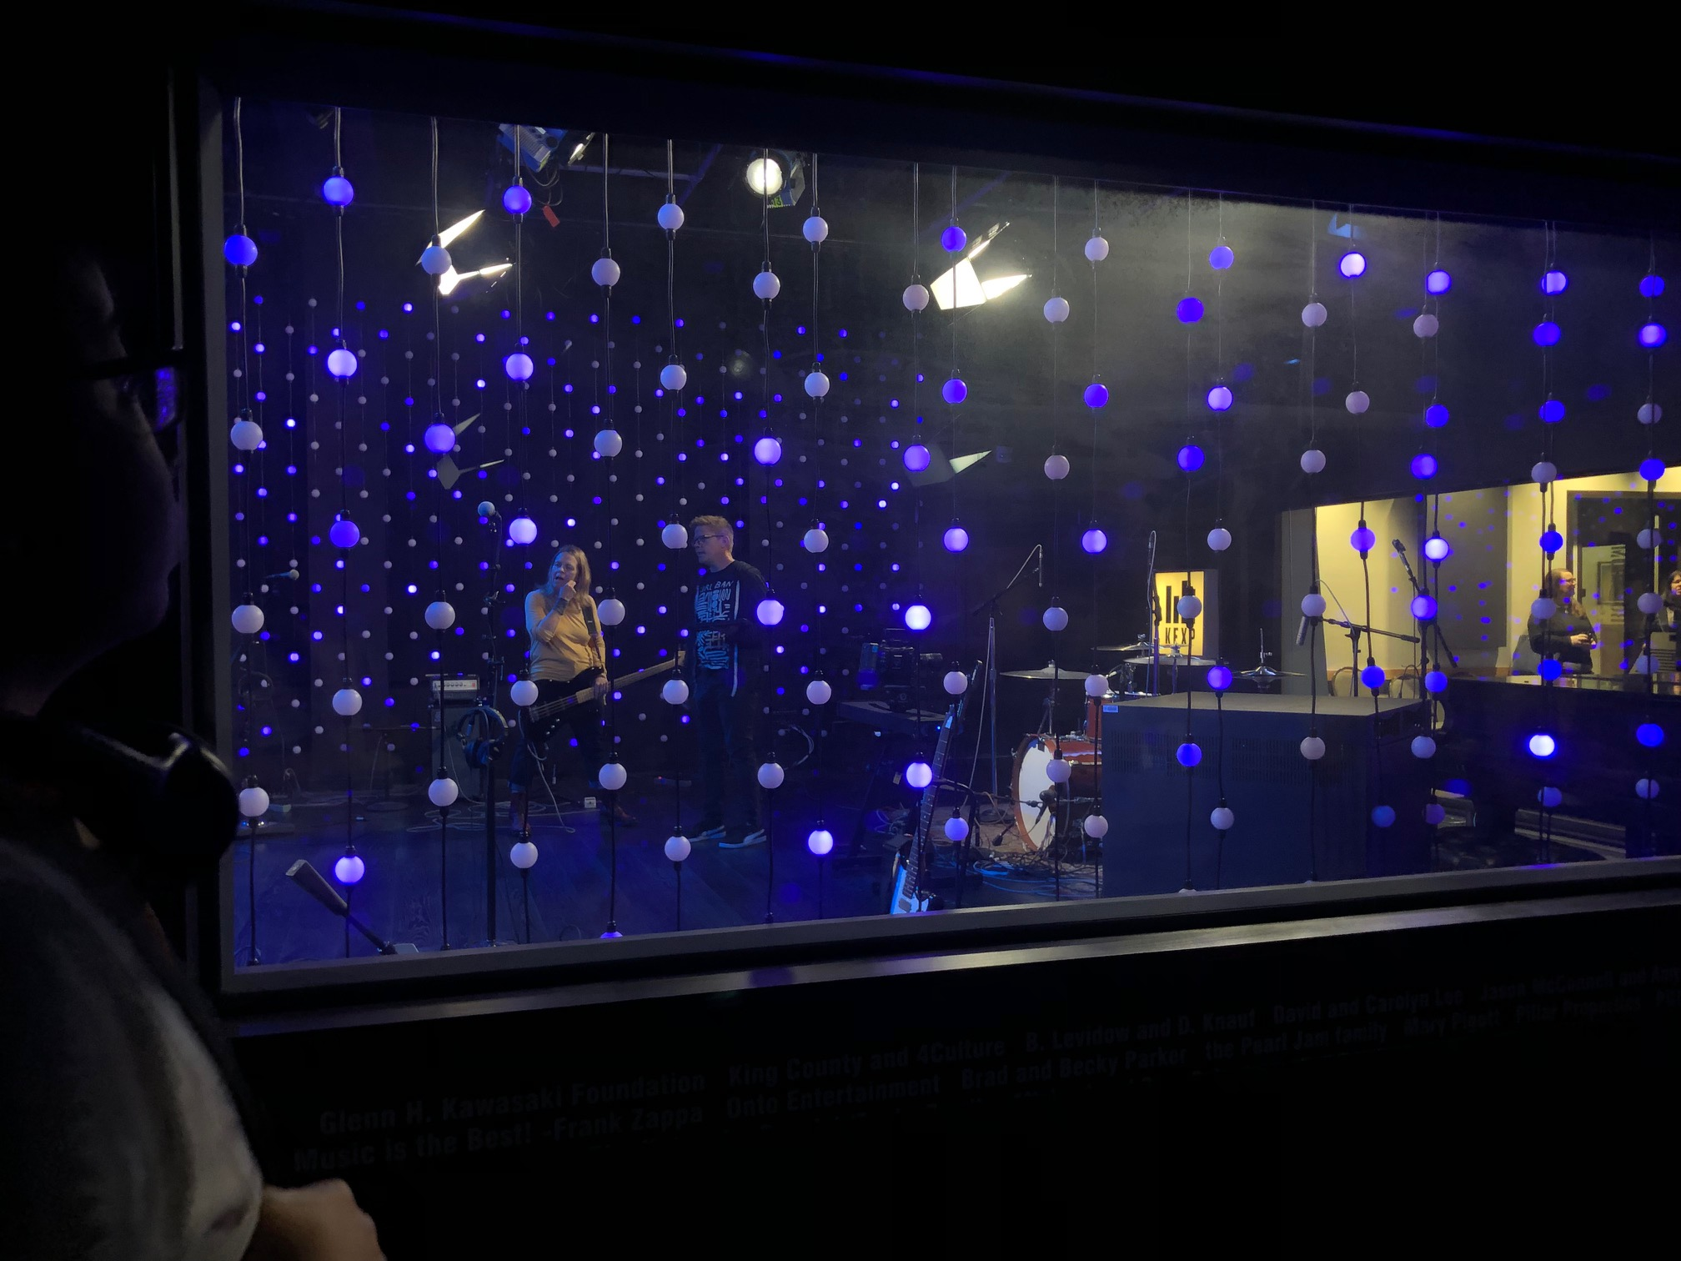We all cheered.

He told us that this used to be a place for art galleries, and KEXP that bought it in 2002. He also told us a little bit about his history, then led us to the first stop: the DJ booth, which looked like a floating, old, wooden house.

“Fun fact, this DJ booth was made from salvaged soundproof wood floating on a lake for 50 years. The holes are dug in by mollusks. This is where the broadcasting goes on, and everything is picked live by the DJ. We usually go into the booth, but unfortunately today we’re too busy.”

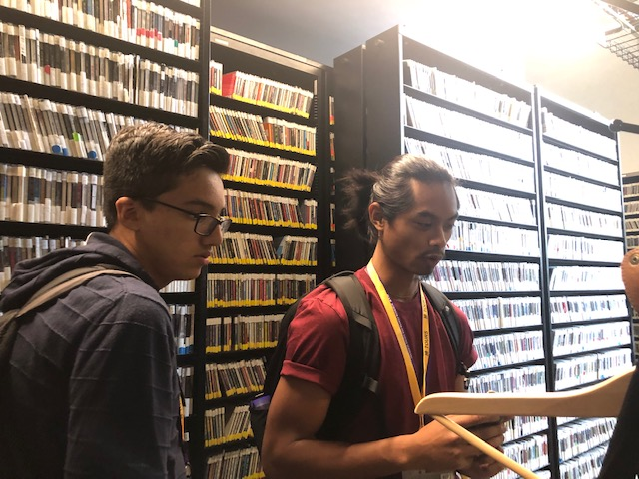He led us to the live recording room, a square room lit by LED lights on the walls strung together by sting. It had an underwater feeling, which was really cool. Inside were people preparing for a band. We went inside *another* DJ booth for music editing. This one had cool features which Triston explained to us, like the unique structure, a panel on the back with a long name I don’t remember which filters the sound to make it sound clearer for the DJ. The DJ, a slim Australian man, even let us try to use the different tools on it! Everyone oohed and aahed when the DJ showed how the features work.

Finally, we went to the cd library, which was really amazing with its countless cd’s. Triston talked to us some more in introduced us to one of the hosts for a podcast program just launched today.

After that we said goodbye at went back to the University to eat lunch. This time I sat by my new friend Ivan and we watched our favorite YouTube channel: TheOdd1’sOut. At lunch everyone got burgers after hearing how good it was. In the afternoon we talked about our trip to the station and made concept maps on what we wanted to do for our podcasts.

Finally, we went home. I slept early because I was really tired from such an exciting day.

# **July 16, 2019 Podcasting Week Two Day Two**

#### Today I finally woke up NOT tired. Yay. I rode the bus to UW because mom had work to do. I followed google maps to Sieg Hall and started writing the writing prompt of the day: “Write down 6 open ended problems for your interview.” Ari gave me a challenge to write down 10. I failed.

After that, we sat in a circle and we discussed how we are feeling today. I gave straight thumbs up because I got good sleep last night. Today Ari told us that we were interviewing people for our podcast, and that was very important. We talked about how to do a good interview, and some tips for doing that.

Ari gave us a sheet of paper with some tips on it. I looked at my sheet, and grinned. There were some really good tips in here, like what questions to ask. Ari went over some of the confusing tips with us. After that we practiced interviewing people by having a standard interview with each other, then having a “producer” (one of us) check out all the things on the list we did and didn’t do.

Then, we went to a classroom and we interviewed *college students*?

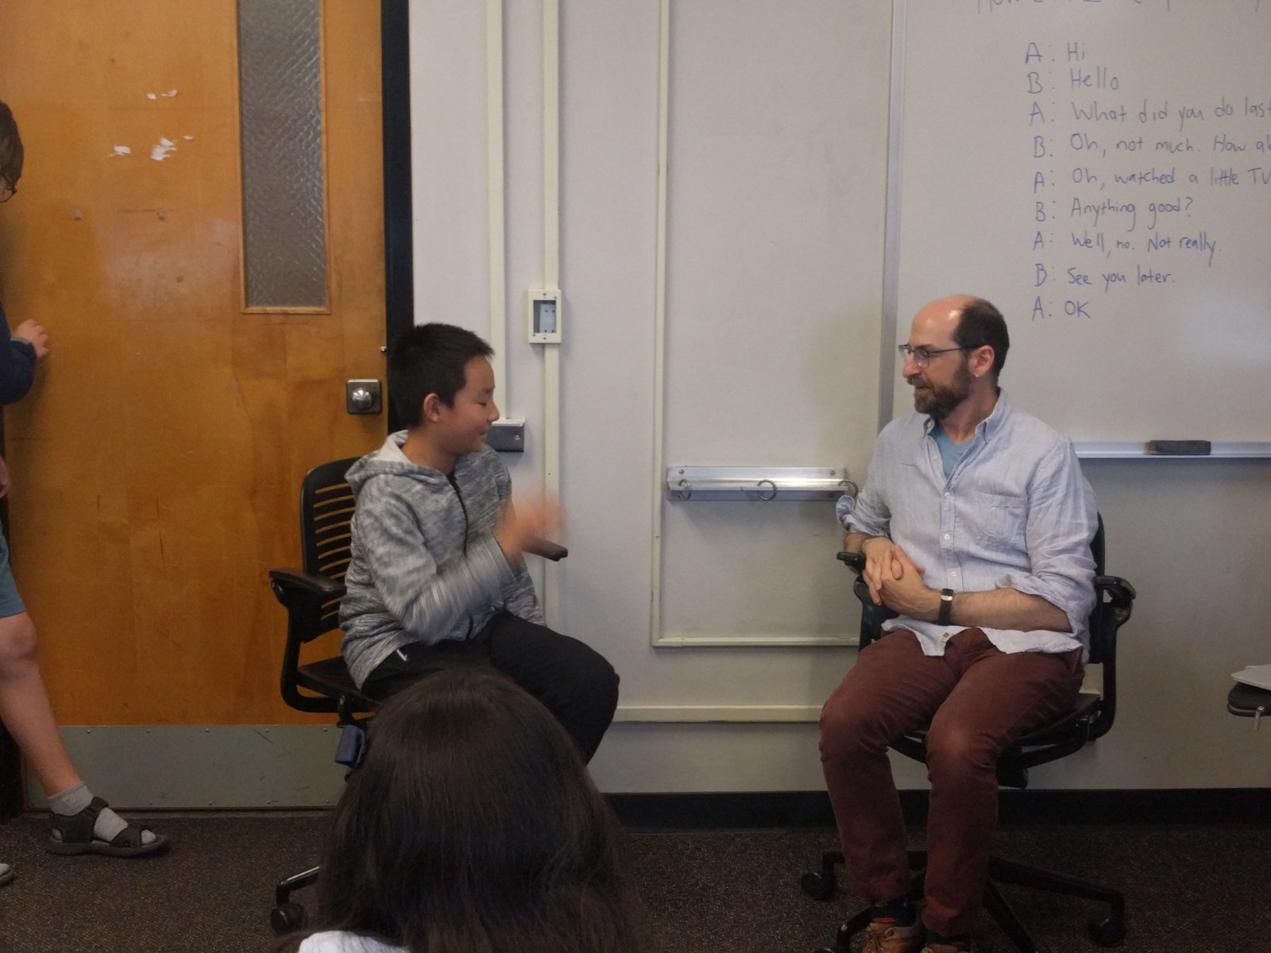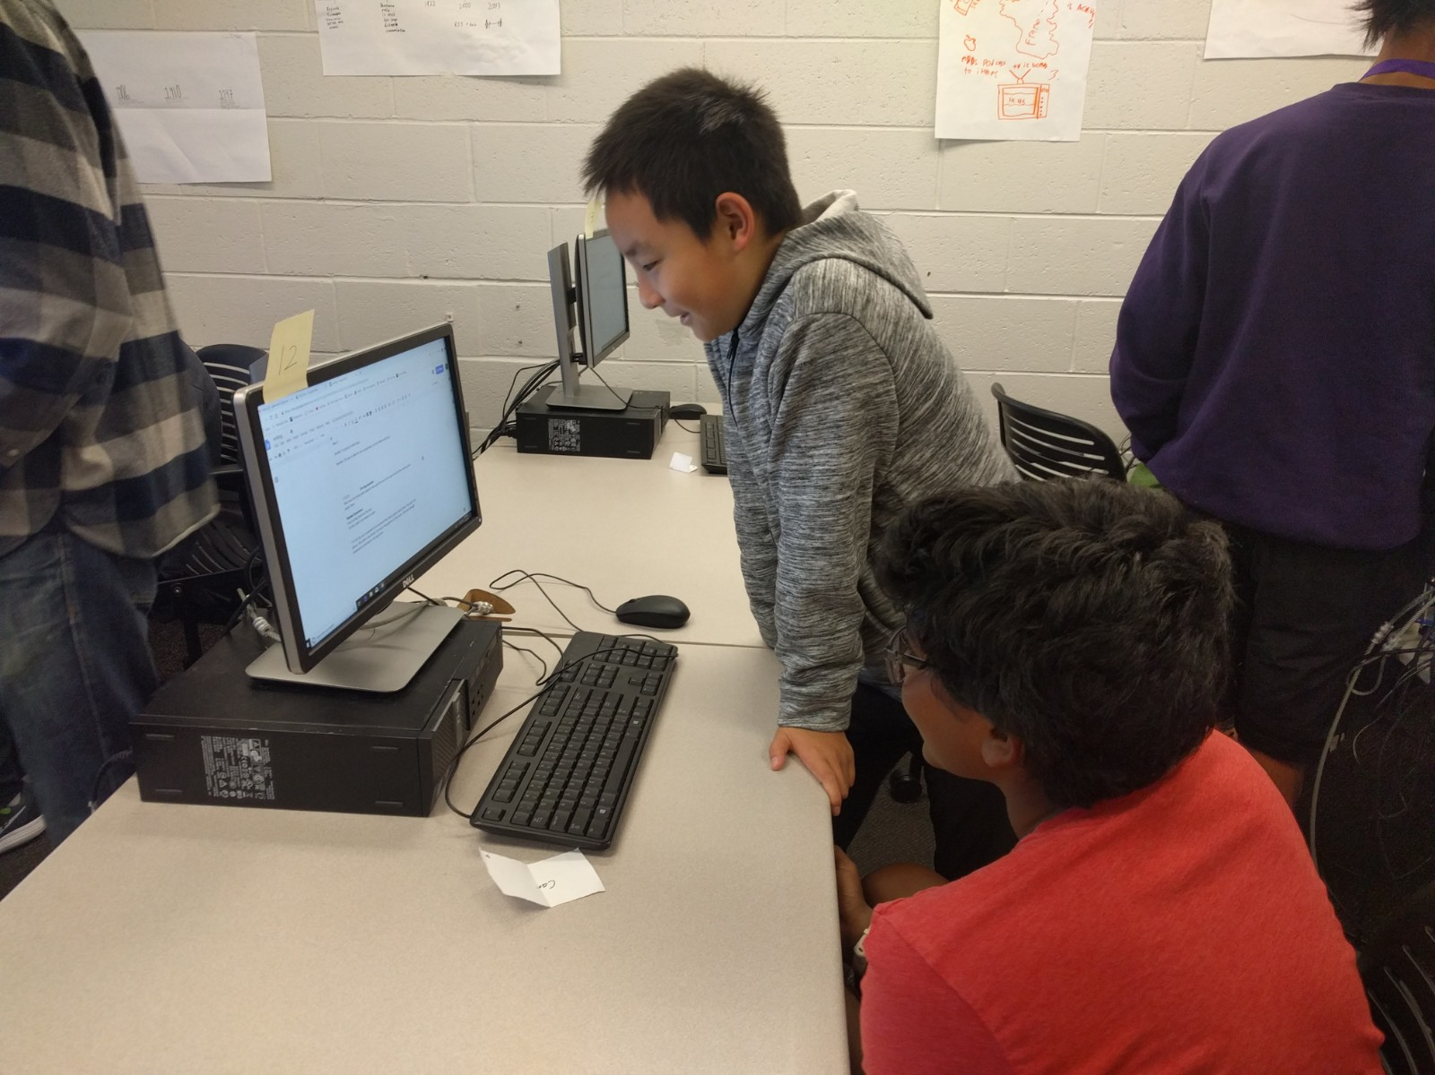Dang. All my plans went down spiral after that. I thought we were interviewing FRIENDS! Why didn’t Ari tell us earlier? My interviewee was a nice Chinese guy called Yi Cheng. He was enthusiastic but didn’t own a cat. My plans were screwed, since all my questions included buying cats. Also, I was bad at recording and parts were recorded in different folders. But still, we improvised, and I got some good tape (which means content). The guy looked like a cool, quiet man: with dyed hair and a skinny build wearing old-fashioned jeans, but he was nice and gave all of his story. So, don’t judge people by their looks. That’s the most stupid thing you could ever do.

Today at lunch I sat alone, since Ivan was my only friend and he was gone. Suddenly, Ilya, a blonde boy came along. I saw his phone and on it was Soul Knight, my favorite video game. I soon went on a ramble and we started to talk not awkwardly (a big achievement for someone like me).

We made some jokes and laughed, and I gave some tips about the game. We quickly became friends together, so having something in common is really important, I guess.

I went home and went to sleep early knowing how great it felt today getting actual sleep.

# **July 20, 2019 See My Old Chess Coach**

I woke up in dread, and excitement, knowing that my dad is coming here today but I finally get to see my old coach. We ate our final buffet at the Bellevue Hyatt Regency hotel. After eating some sugary cookies and pancakes, I felt a little better, and was ready to head to chess class. As we arrived at the good old’ Chess4Life, which was now bigger. I was tinged with sadness. It was like seeing a home that you lived and laughed in for more than two years being sold and reconstructed. I saw my dad already talking with Coach Sloan, my starting coach who taught me all the basics and beyond. I saw Sloan and was surprised to see that he now has a short haircut, and currently does not look good: red eyes, sagging eyelids, and a slouching position. Nonetheless we were both happy to see each other again. We said our hellos and quickly began class. We haven’t seen each other for more than half a year, but somehow, we still knew exactly what to say to each other.

“What do you want to work on today?” Coach Sloan asked me, smiling.

I shrugged casually and said: “Meh. I don’t know.

Much to my excitement, we decided to play a practice game. I was excited to test out my new skills. Not to brag, but I *have* grown quite a bit the last six months or so. A few moments later though, I was biting my nails and feeling embarrassed.

After a few seconds of awkward silence, Coach Sloan said: “Call it game?”

I grinned, “Dang it, I was almost winning!” I said sarcastically, and we both laughed. I almost forgot how fun it was to be in this classroom. Sure, my other Coach might be more professional, but here I could goof around. Then, we reviewed our game, and we analyzed another game after that one. Each time he patiently waited for my thoughts and explained the games thoroughly.

Time passed by way too quickly, and it was time to say goodbye.

As we said goodbyes, Coach Sloan yelled: “It was good to finally see you again.” I was touched, but grinned back. I was looking forward to seeing him again.

That afternoon, we swam for a bit. Luckily, my mom fixed the “accident” (I’m sure it was dad) which almost made me have to swim for DOUBLE the time! We ate lunch with Kylie’s family, (which I recently moved out of). We talked about the latest video game and played with the nail polish. To my dismay, though, I soon discovered that nail polish was almost *impossible* to remove! We washed some of using the glitter polish, but I left the restaurant feeling quite ridiculous about my new half-black nails.

# **July 21, 2019 A Nice Saturday**

Beep! Beep! I rolled over and *slapped* that stupid alarm clock.

“Wake up, guys!” My mom yelled at me, my sister, and my dad.

I groaned, but slowly got up. I glanced at the clock – 10 o’ clock. In a grumpy mood, I watched some TV. I deserved a break, after taking three classes in a row nonstop.

Before we knew it, it was three o’clock. Not feeling energetic after having watched so much TV, I was hesitant to get in the car and go swimming. It didn’t help that dad was driving at an infuriating speed, causing us to be late. After what seemed like an eternity, we arrived at YMCA. My friend Sean was already waiting for me down in the pool.

“Good news, lap pool is broken today.” Sean informed me.

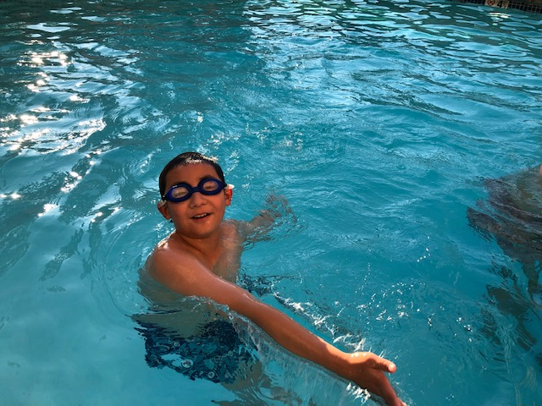I grinned. That was good news. That means we get to relax in the kid pool, and don’t need to swim a bunch of laps.

After swimming around pointlessly for a while, I had an idea. I swam over to Sean and asked him, “I have an idea!” After I explained to him the rules, he agreed. We played ten rounds of underwater basketball, where we will shoot the ball into the goal in the water. It was a blast, juking your opponent with a swim move, sharpshooting in a moving river. In the end, after some brief arguments and lots of laughing, we went out of the pool. We were planning to go Sean’s house and chill for a while, but dad told me: “Nope.” Shock turned to anger, and fierce argument followed. In the end, dad lied and dragged me into the car the last moment. I was furious and shouting, tears streaming down. This was one of last times I could meet with my friends, but my dad had to too lazing to pick me up two times.

My dad was stubborn, and in the end, we had to wait in the car for half an hour before going to one of dad’s friends’ house to eat. They had a third-grade kid called Lucas, who looked familiar, but I just couldn’t put my finger on why though. What surprised me though, was his room. He was doing Algebra, Biology, Chemistry, and lots of other stuff I don’t know about. And it was all real! Not the kid version! Honestly, I was proud of myself for being gifted, but this just made me feel stupid. We talked as though we were both in middle school, and we played Halo, played some chess, and made jokes on Legos. The last part was very memorable as we made up ridiculously ridiculous weapons. As a bonus, they had nail polish remover! I don’t have to look like an idiot at class tomorrow!

I actually regretted leaving, and we went home tired and happy.

# **July 24, 2019 An Unexpected Event**

“Ding ding ding!” “Ding ding ding!” I woke up by a loud screeching sound. “Wuh?” I mumbled incoherently. My mind quickly cleared, and I sprung up and began to walk outside: the fire 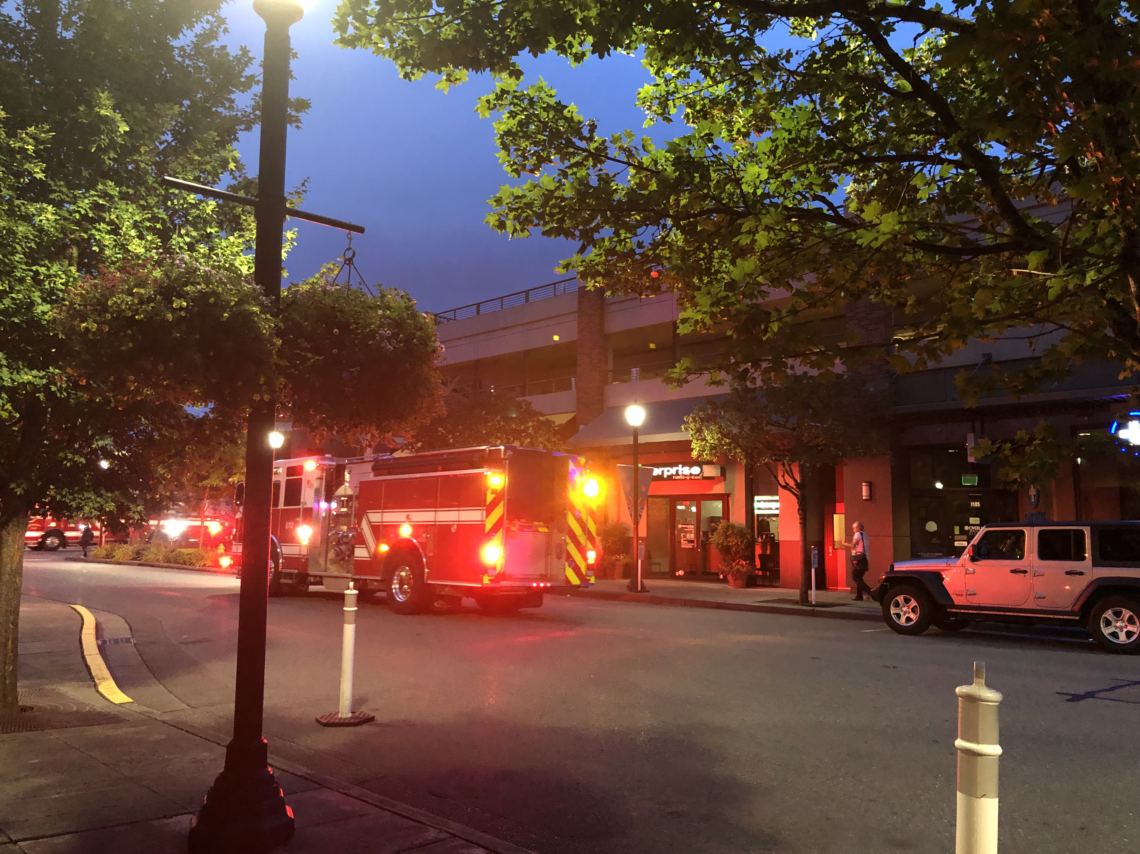detector was triggered. A bit of irrational fear ran over me, reminding me of a small earthquake not long ago, and I walked a bit quicker. Usually it was someone accidentally triggering it, for example they over microwaved something, but what if it was a real fire? I walked over to the staircases just in case there was a real fire. I saw people like me walking, too, none were worried, instead having amused or annoyed looks on their faces. I tiptoed down the staircase, having forgotten to wear shoes. As I walked outside, a cold breezed confronted me. I shivered; I was only in my pajamas! As I walked towards the hotel entrance, I saw my dad in full clothes. He had a casual smile on his face, but the laugh at the fact that I was in pajamas was forced. He told me it was five o’clock, and luckily, he had a towel, which instantly made me feel better after I put the lifesaver on.

I was a bit worried because mom and Mira are still not out yet. I nervously paced back and forth and, after what seemed like centuries, my mom, carrying my sister, finally arrived. I let out a sigh of relief. My sister looked confused and sleepy and didn’t allow my mom to go check if it’s a real fire or not. Soon later though, firemen came, and walked out casually, some even with hands in their pockets. After a painfully long time, the fire alarm finally stopped its screeching. Relieved, me and my mom navigated through the crowd and finally got upstairs for some well-needed sleep.

That morning dad had to scream and drag me into the car, which took like 10 minutes. Fortunately, the bus was late, and we were able to catch it in time. I couldn’t remember the events of that day, because my head was throbbing, and I couldn’t think straight. I didn’t learn anything that day at camp, and I only remembered recording my script and not downloading it, and also Ari helping me with some stuff because I fell asleep.

So, the moral is, get some good sleep. Doing the opposite and working extra only backfires. Also, wear some thicker pajamas, just in case ;).

# **July 26, 2019 The 2nd Last Day of Summer in America**

I jumped into the car, sad about the fact that it’s the last full day in America left. I sighed. At least we going to have a potluck today. That didn’t make me feel better. Feeling down, I entered the bus and took a power nap. Hopefully, that will make things better. But nope, I was wrong, and I left the bus feeling even more depressed about the fact that that was the second last time I’ll be able to see my old 5th classmates on the bus. I entered class, pulled a stick, and gloomily walked over to the table, starting to mechanically type in words for my writing prompt. Ivan sat next to me. After a while, Ivan noticed my rather unusual attitude and tried to cheer me up by showing me some videos. I forced the most convincing smile onto my face, then quietly went back to work. I tried to work as quickly as I can, hoping for some “free time” after I’m finished. Export files… done. I clicked the button and satisfaction hit me. Suddenly, I was interrupted by the beeping of the door.

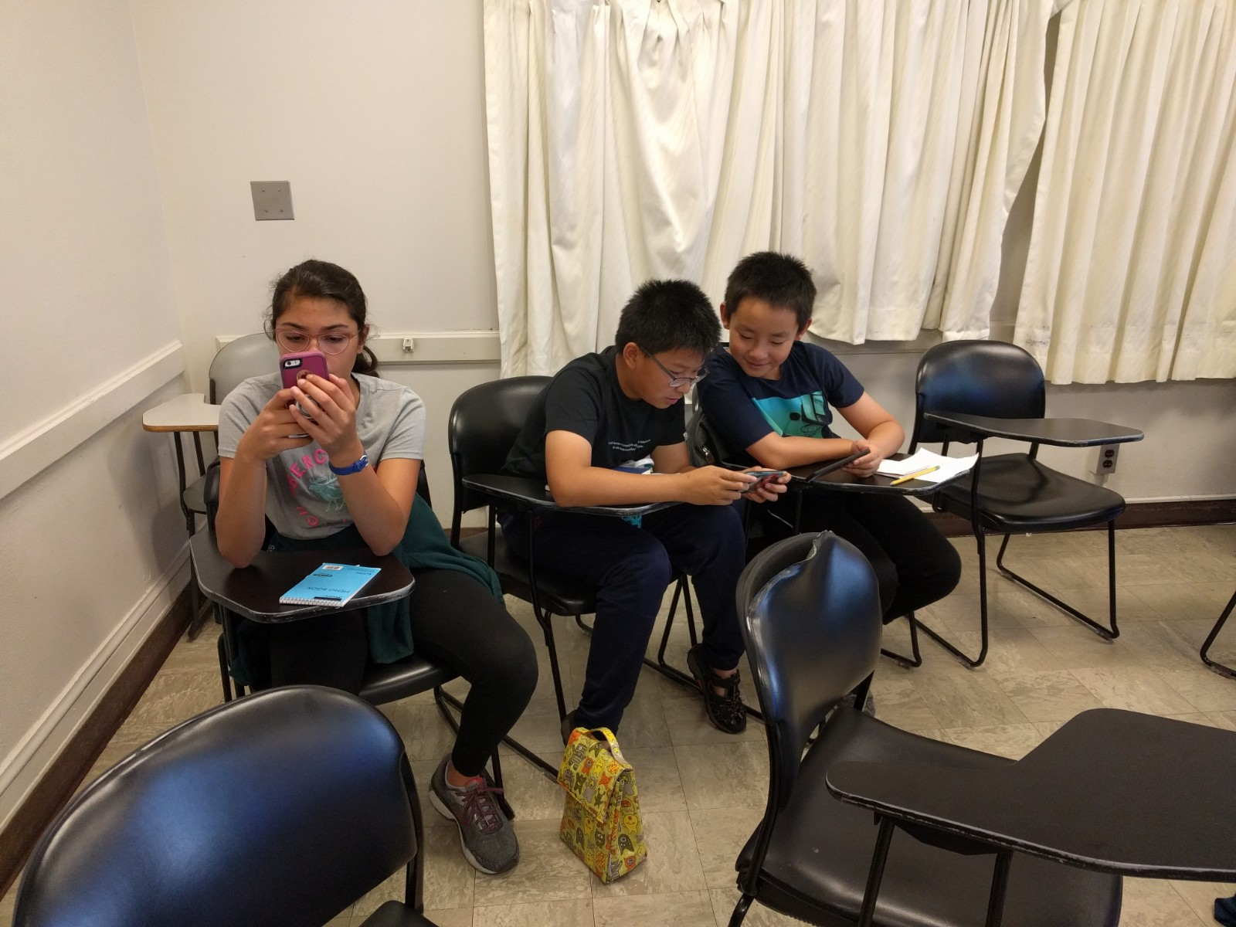Griffin swung in and said in a sing-song voice: “Oh M-a-x, c( )o( )m( )e to the hallway for your mini-conference!” I grumbled but responded with a barely interpretable “Yes.” I entered the hallway and saw Ari sitting on a chair, waiting for me.

After 5 minutes, I left feeling good about the conference: I answered all the questions honestly, suggested some changes, and all while retaining a positive attitude. I called out the next person and went back to my desk, trying to convince Davian to let Ivan and I play video games. After reluctantly doing some extra projects, Davian finally gave in, and of we go to play some video games!

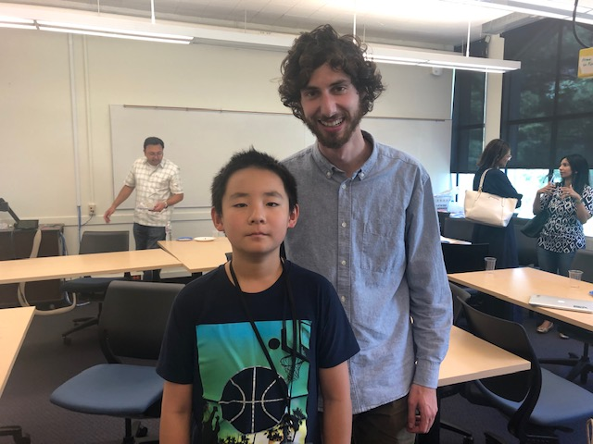Before we knew it, the potluck was starting, and it was time for the potluck! I started sweating, which had nothing to do with the temperature. Honestly, I was kind of disappointed about my podcast, mostly because I screwed up the audio. Showing it in front of everyone, didn’t make it better. So, the whole time I lowered my head down, watching YouTube videos by myself. But I couldn’t stop the inevitable, and soon it was time for me to present my podcast. Everyone looked at me expectantly, but thankfully I’ve been mentally preparing this moment. I confidently showed everyone my podcast, RSp (Random Stuff productions) and told everybody that my audio was screwed up. Everyone laughed humorously, which made me feel better. The podcast started abruptly, and I cringed at the sound of my voice. Suddenly, everyone started laughing at a classic audio trick I learned from YouTube. I lit up, and for the rest of potluck I would think of the joke and smile. Heh. It was pretty funny.

That afternoon I was too lazy to write one of these diaries and I soon would regret it. (Foreshadowing)

# **July 28, 2019 Going back to China**

I woke up late, not wanting to start the day. I ignored the sound of the TV, the light outside, my parents talking. I burrowed my head into the pillows, suffocating myself. After twenty minutes though, I finally gave in, and woke up. I took a small bite out of peach then followed dad to chess class. Today I’m going back to China. Just me and my dad.

Time flew quickly, and before I knew it, it was time to say goodbye to Coach Sloan. We drove home and packed our luggage. Mom was in tears, even though she’s going to visit us once in a while. I refused her hug, trying to make myself look tough. I ignored her droning in about my safety. We head down the elevator and went on the car. I looked at the hotel meaningfully. This might be the last time I see this place for a long time.

We drove to Sea-Tac Airport. I sighed. I can’t believe three weeks has already passed. We were the last to board the plane. Sometime on the plane though, I cheered up. I thought to myself: “It’s ok. I’m going back this winter vacation anyways. Mom’s coming to visit next month. Plus, the middle school’s great here, and I get to see my grandparents again. Cheer up!”

Dad woke me up, telling me we arrived. Hm. I fell asleep. Feeling slightly disoriented, I stood up and stretched. Everything seemed blurry, probably because I watched three movies in a row, and the fact that I have jet lag. I followed dad half-asleep, walking in a zig-zag pattern. After finally finishing those what seemed like infinite security checks, we finally exited the airport. This is home. It didn’t feel like it. Even though it was raining heavily, we were greeted by a blast of suffocating, hot stinky air as we went outside. I sighed. It was time to switch back to China mode. Gotta get used to it. On the bright side, this could have been worse. If we weren’t early, the rain and lightning could have caused an airplane delay. We got on one of the many taxis and drove to our new home. I opened the door and breathed the familiar air of China apartments. This home was significantly smaller than the last one, but nonetheless it was cozy. My grandparents lit up as they see me, and I had to fight to reach the bed without being suffocated from my grandparents’ hugs.

I and my dad slept in one room, and the exhausted me quickly fell asleep.

# **August 7, 2019 Chess Tournament – Arriving in Huangshan**

I was both excited and nervous: it was time to go to Huangshan for my chess tournament. My dad already left, because this time I’m going with my grandparents. I ate little of my breakfast and rushed my grandparents. “Come on! Let’s move! The elevator’s here already!” I yelled, keeping the elevator door open. We went to the railway stop by subway, and time passed agonizingly slow. Finally, we got there. “Beijing South Railway Station.” We were just in time, and I leaded my confused grandparents to the train stop. It was a five-hour ride to Huangshan. My grandparents took a nap, while I watched some videos. I was still getting used to no YouTube. As we arrived and got off the train, we were greeted by a blast of boiling hot air. I sighed. And I thought Beijing was hot.

Everything went smoothly, except for my grandma bragging falsely about how good I am. 3 pm, we arrived at the hotel. I was tired, though I didn’t know why. I let my body slam onto the bed, and before I knew it, I was asleep and snoring. I slept for an astonishing 3 hours and had to be woken up by my grandpa to eat. We got onto Old Street, which was supposed to be one of the earliest streets built. Honestly it looked average, with half broken walls and small, dusty shops on the side. There was a river on the right with a stone bridge with what seemed like dragons carved on the side. Along the lake was fishermen fishing with wooden rods. The lake looked nice, and I was able to see the bottom of it. After eating an average meal, we walked back to our hotel (Huangshan International Hotel). After a while, we heard someone knocking the door. I scrambled over to open it. Peeking out, it was a boy my age that looks familiar, but I can’t quite remember.

“Hello.” He said

“Hi.” I said, not wanting to tell him that I forgot who he was.

“Wanna play a practice game?”

“Sure.”

It all went smoothly after we started talking chess, and we played quite a few rounds. After about half an hour, he went back to prepare for the prep talk at 9 pm. Our coach was going to explain the new rules. We were the first to arrive at Coach Xu’s room. Gradually the room filled up with more people. I whistled under my breath. There was a lot of people this time. I saw some familiar faces, too. Even though I knew it didn’t matter, it felt good to finally be in the same ranking as my club-mates. The meeting was invaluable; the rules changed drastically and was more professional to attract more people. I felt bad for those people who don’t know.

The meeting ended quickly so we could go to sleep early. I fell asleep quickly, despite the nervousness and excitement.

# **August 8, 2019 Chess Tournament – First Day**

I woke up with butterflies in my stomach. I stretched lazily, trying to resist the urge to sleep. I crawled over to the clock: 7:14. I sighed. “Wake up, sleepyhead.” I told myself. It’s the big day. I woke my grandparents up and brushed my teeth. I walked sleepily over to the breakfast area, with no real appetite. I poked at my noodles impassively. In the end, all I ate was two noodles and half a grape. I walked over to the chess court and took a deep breath. This is it. I checked my number and stepped inside. The place was large and fancy- a long rectangular room with the managers on the other end. Almost everyone ignored the managers droning on about the history of the tournament, clapping mechanically at the right moments. We sang the national anthem, and I tried to fit in by singing quietly. Soon after the manager announced the words, we’ve been all waiting for: “Round one, start!” Clocks starts ticking, hands shake, and the room is instantly quiet.

As black, I was forced to play defensively, and was in pressure. I entered a meditation-like state, and the noise faded away. The thought struck me like lightning. D5! I proudly pushed my pawn forward. I grinned. One small step for the pawn, but one big step for me. I forced a draw, and I could see the defeat one his face. Round one, all good. I walked happily back to my room, preparing for the next round.

Round two though, was *not* going well. After a series of horrible mistakes by me, I lost to a six-year-old boy with a proud smile on his face. Slowly, he broke my desperate defense, and I exited heads-down. It’s okay, I said to myself. But you know, it’s really hard being okay when one, you were white, who has an advantage, and two, your opponent was a six-year-old.

I forced the nervousness down my throat, ate some chocolate, and went on to the third round. Whoop. Here we go. To my surprise and disappointment, I was playing a club-mate. I gave no mercy, using one of the sharpest lines in the game. He didn’t know the line, and everything was going well. Then, I played a what seemed like natural move. His eyes lit up. I rechecked the position. The realization sunk in. I blundered.

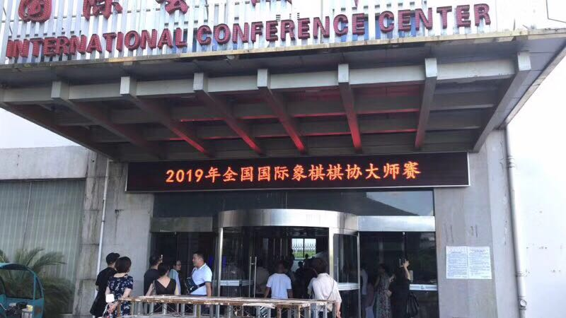

# **August 8, 2019 Chess Tournament – First Day (Cont’d)**

Continued. I blundered. My opponent checked for traps. There was none. I lost half a piece, which was losing at this level. Disappointment and frustration were the only two things I was thinking about. Making a low-level mistake was bad enough, but now I lost 2.5 points, 2 from losing two games and one from the draw, there was no way I could advance my ranking now. Unless I win all my games onward, and then drawing the last. And by the looks of the first three rounds, that’s like asking the Browns to win the Super Bowl. I despondently signed my name, and trudged out of the court, surrounded by depressing thoughts. I headed straight back to my room, trying to burrow myself into a pillow.

Luckily, god was kind, and the next round was easier. Still, every club mate who waved while they went on to their own tables, which were much higher than mine was a blow to my ever-shrinking esteem. I sat at the gangster table, where everyone laughed and did whatever they wanted because they knew they had no hope anyway to rise rankings. My opponent was the same, and played carelessly, and soon lost a pawn. There was still a little hope, and I clutched onto that desperately as it was that string keeping me from falling into the abyss. I fought ferociously, and soon my opponent fell. Relief flooded into me, and for the first time of the day I walked out as happily as I could have been in that situation.

We ate at a small shop, which was dusty but seemingly popular. The food was nothing fancy, just like home. I gobbled down the food and felt satisfied. Nothing better than home-made food.

I walked back with a full tummy, watched some TV, and went over to review my games. Turns out, after this round I wasn’t doing *the* worst. And seeing how easy the other people’s opponents were, I felt a bit jealous. Suddenly, the guy who played chess with me last night, who I will name…Fred, rushed in and announced:” I’m playing Max tomorrow!” I sighed. So much for easy wins tomorrow. At least I knew what he was going to play (the Scotch), and he was nice enough to later teach the line. I would have been screwed otherwise, already losing a game like that.

I was exhausted, mostly from the pressure, and quickly fell asleep.

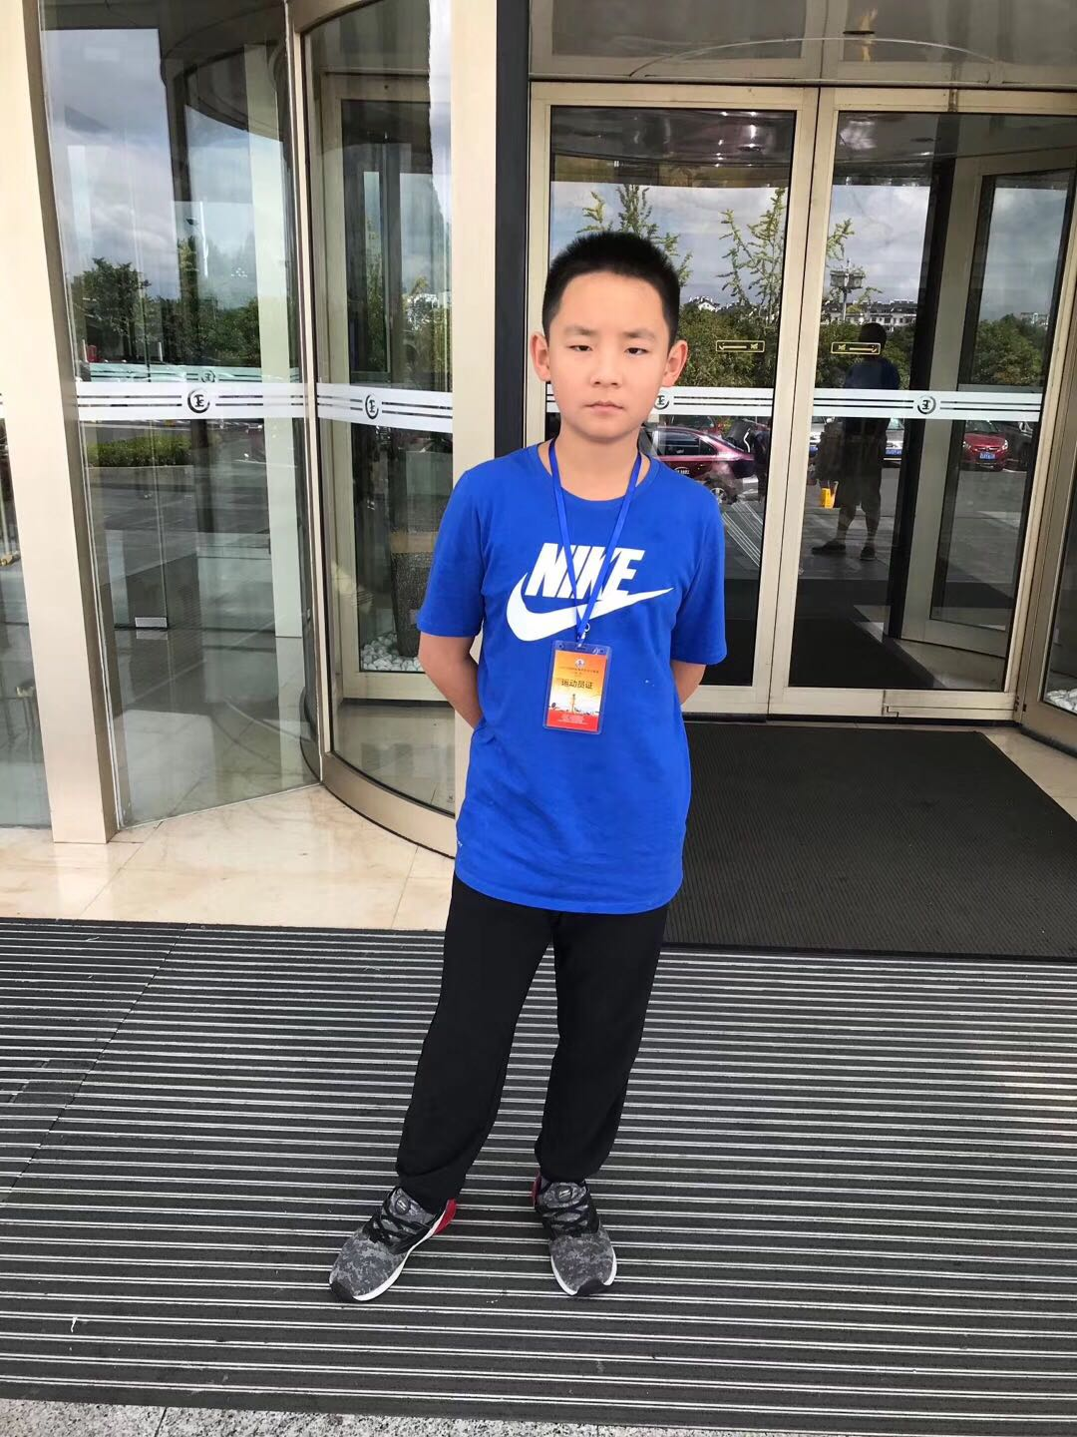

# **August 9, 2019 Day Two of the Chess Tournament**

Hello? I was in the chess court, but no one was there. The room was as bright as day, even though there were no lights. I sat down cautiously, and suddenly; the guy I was going to play today appeared. We played chess, and joked around, but then I lost for some forgotten reason. I headed back to the hotel disappointedly… “Ding ding ding!” I woke up abruptly, surprised and confused. I sat still for a second, reorienting myself. Phew. It was just a dream. I realized that my head was throbbing; I didn’t get enough last night. I forced myself out of bed, and glanced over to my grandparents, who were just awake like me. Reaching over, I turned on the lights and got up. After brushing my teeth and splashing some water in my face, I felt awake, and went to eat breakfast. I had an even smaller appetite today, and barely touched my noodles. I walked over to the chess court nervously, still cursing my bad luck. No need to check anything, since I already knew.

The game started without us even thinking about the moves, having already prepared for the opening yesterday. Still, I understood little about the opening, and quickly had problems with my pieces being cramped. Twenty moves into the game, I was already sweating while he looked fine, probably because he only spent three minutes thinking to my whooping thirty. I wouldn’t give up without a fight though, as long as hope was there. Slowly, we traded pieces, and I used his space advantage to *my* advantage, locking the position up and separating his pieces, which were deep into my territory. Move by move, he had to use more and more time, until we were nearly even. Despite our best efforts, there was no real weaknesses and it should be a draw. He offered a draw. At this point I was tired and sick of all the pressure, and drawing was the way out. “I still have a chance after this round,” I said to myself. But deep inside, I knew that it would be at *least* extremely unlikely that I would win all the games, especially the last one. No, my best bet was to win all the games today and draw the last. So, I refused. His head tilted in confusion, but quickly went back to thinking. It soon became clear that I calculated quicker than him, and I grinded his time until it reached five minutes. I felt bad, but I had no choice. I opened up the position with a pawn sac, complicating the position. He was visibly sweating by now, but it was over. He soon lost a piece, then another. Finally, he sighed in defeat, and resigned just before the clock reached zero.

I sighed too, in pity and relief. We were good sports and talked about the game on the way back.

The next game I felt like I put my best into it, playing without pressure or hesitation. I felt like Hitler when he started World War, and my opponents fell one by one. I could see the disappointment on their faces, which was totally relatable to anyone who played chess. It was the last game, and I felt like I was losing. I offered a draw, but my opponent refused cockily. So, I played, not letting his attitude affect me. After a few questionable moves, though, he wasn’t so cocky.

I excited feeling good. I wasn’t someone that was affected by praise that much, but this time I *glowed* in front of my friends’ praises and congratulations. I just had to draw the last one, which was easy, since any logical person would draw as quickly as they could in my situation. My only worry was that I played badly in the first twenty moves and they decide not to draw. My coach gave me some mental preparation and told me to sleep early. Which I did. Gladly.

# **August 10, 2019 The Last Day of the Chess Tournament**

I woke up with little pressure compared to the last two days. I had a better appetite today and ate a full plate of noodles and an egg.

I walked over to the chess court, and a bit of irrational fear entered me. Still, I had no choice but to enter the chess court. My opponent hadn’t arrived yet, and I could already see other people talking about how to draw the game. Minute by minute more butterflies appeared in my stomach while I scanned every person walking over here. Finally, a boy my age sat across me. I asked him:” Draw, right?” He smiled. “Of course.” I let out a *huge* sigh of relief. I did it. I did the nearly impossible. We decided to follow the moves of the person next to us, and to draw as soon as we hit twenty moves. The games started, and I could see the director’s eye widen as he saw our row play the *exact* same moves at nearly the same time. I suppressed a grin, and my hand almost slipped. On the 12th move though, my opponent played a novelty. Surprised, I started looking at the position. Nope. Nothing special. Whew. So, I played a passive move, hoping he would do the same. I could already see someone on this row finish, and I did a meaningful glance at my opponent, telling him to move quicker. He nodded and played Qc2. At this point it was 18 moves, and I decided to make our position more convincing and different by playing a5!?, which is an aggressive pawn push. I could see his eyes widen, but he said nothing. At this point, we were the only board left on this row. My opponent thought for quite a while, but in the end, he responded with a4, a natural, defensive move. Next move I played b4!?, and he responded with b5. Now was the moment. My opponent stared at the position. Time seemed slowed to a sloth pace, and I could hear my heart beating. Finally, he offered his hand and said the five words I’ve been waiting for since last night: “I offer you a draw.” This was it. I accepted the draw. I walked over to the club-mate I played yesterday morning and gave a thumbs-up. He smiled and mouthed: “Congrats.”

We went back and ate lunch in a hurry, since the train was at two pm. I said a quick but emotional goodbye to everyone and left the hotel grinning. Even now, as I’m writing this, I still feel proud about that day. You know what they say: “Your hardest times often lead to the greatest moments of your life. Keep the faith. It will be all worth it in the end.”

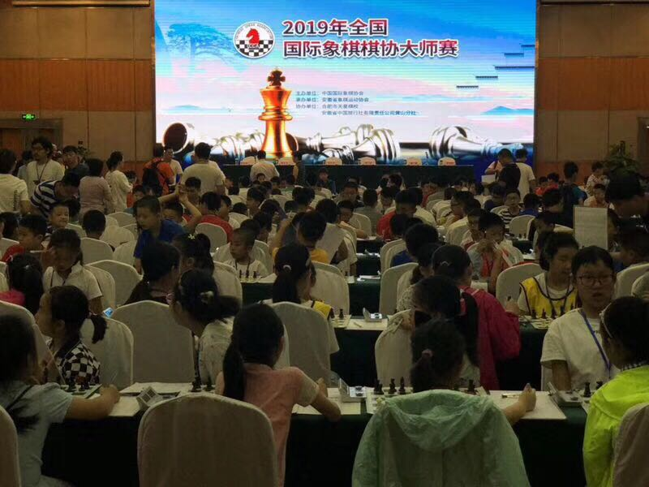

# **Afterword**

Whew! As I’m reading this to you, I’ve realized how *long* this journey has been and how quickly it went by. Below it is a picture of me with friends in the camp of University of Washington. What a ride!

